**Online Real Estate Portal (MagicBricks)**

The purpose of designing the real estate portal is to give the buyers a platform for finding a value of money and good location houses. It also connects the buyers with the major property dealers. Buyers can select best property dealers from Available property dealers based on their location and prices.

Objective

The objective of the application is to develop a system using which buyers and sellers can communicate with each other. An Online Real Estate Portales an application where the Buyers can register themselves at the website and search houses which are suitable for them where as the Sellers, Property dealers register with the website and put up houses or the property which are available for purchase. The Online Real Estate Portal System is a package to be used by agencies to improve the efficiency of business. The Online Real Estate Portal System to be developed benefits greatly the members. The system provides house catalogue and information to members and helps them decide on the house they want to purchase

Roles:

1. Seller – Seller can visit the home page of real estate after log in module. It can select the type of property he wants to sell and give the details regarding it.
2. Buyer – Buyer too can login into the system and can search and select the type of property and his budget and also find the location of the property. Buyer or seller make reliable communication to each other through the website. Buyer can also search seller contact details in order to enquire about the property

Asdasdaasdasd

**Home page**



**Login Page for Buyer and Seller**

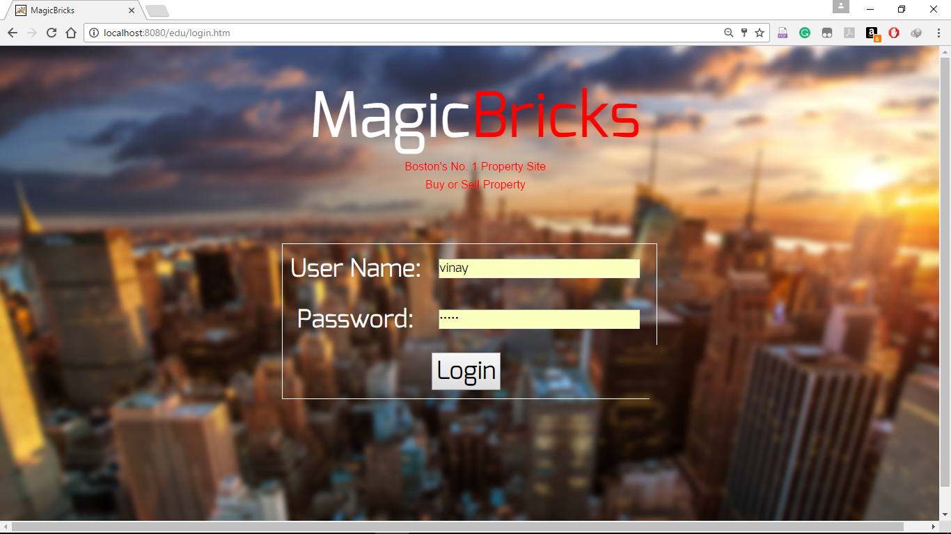

**Seller posting a Property to sell**



**Seller Can have a look at the Buyer, who is interested in buying the property by clicking on VIEW button**

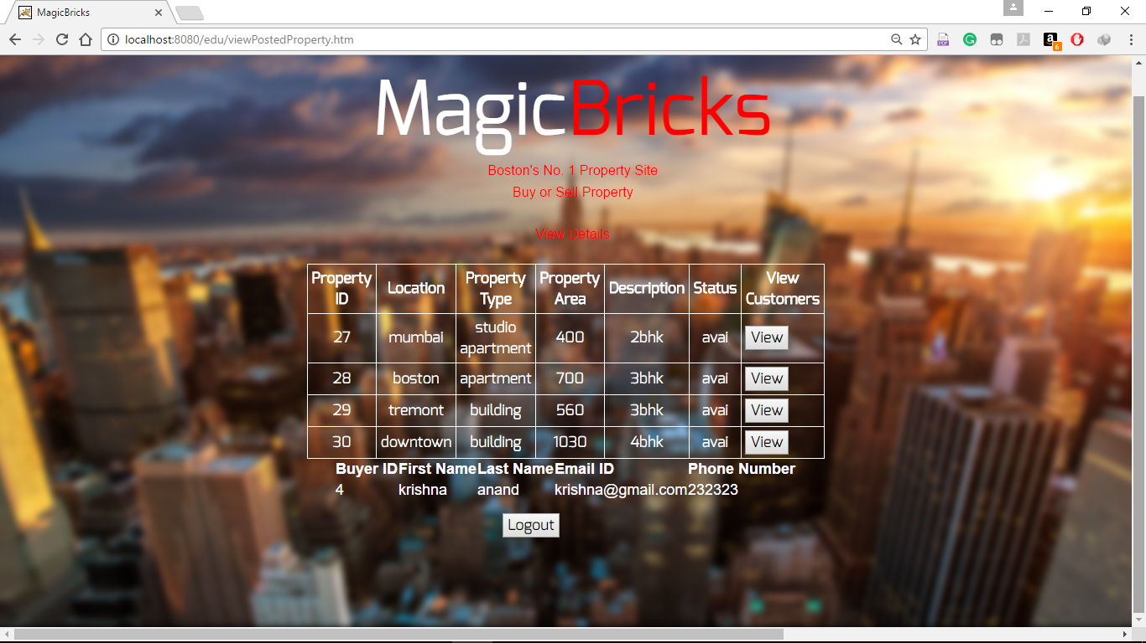

**Buyer Searching for a property**



**Buyer property search result**



**AddBuyerController**

package com.neu.edu.controller;

import java.util.ArrayList;

import java.util.List;

import javax.servlet.http.HttpServletRequest;

import javax.servlet.http.HttpSession;

import javax.validation.Valid;

import org.springframework.beans.factory.annotation.Autowired;

import org.springframework.beans.factory.annotation.Qualifier;

import org.springframework.context.ApplicationContextException;

import org.springframework.stereotype.Controller;

import org.springframework.validation.BindingResult;

import org.springframework.web.bind.WebDataBinder;

import org.springframework.web.bind.annotation.InitBinder;

import org.springframework.web.bind.annotation.ModelAttribute;

import org.springframework.web.bind.annotation.RequestMapping;

import org.springframework.web.bind.annotation.RequestMethod;

import org.springframework.web.bind.annotation.RequestParam;

import org.springframework.web.servlet.ModelAndView;

import com.neu.edu.DAO.BuyerDAO;

import com.neu.edu.DAO.PropertyDAO;

import com.neu.edu.Exception.AdException;

import com.neu.edu.pojo.Buyer;

import com.neu.edu.pojo.Property;

@Controller

public class AddBuyerController {

@Autowired

BuyerDAO buyerDAO;

@Autowired

PropertyDAO propertyDAO;

@Autowired

@Qualifier("buyerValidator")

BuyerValidator validator;

@InitBinder

private void initBinder(WebDataBinder binder) {

binder.setValidator(validator);

}

@RequestMapping(value="/addBuyer.htm",method = RequestMethod.GET)

public String initializeForm(@ModelAttribute("buyer") Buyer buyer, BindingResult result)

{

return "addBuyerForm";

}

@RequestMapping(value="/addBuyer.htm", method = RequestMethod.POST)

protected String doSubmitAction(@Valid @ModelAttribute("buyer") Buyer buyer, BindingResult result){

validator.validate(buyer,result);

if (result.hasErrors()) {

return "addBuyerForm";

}

try {

buyerDAO.createBuyer(buyer.getUser().getUserName(),buyer.getUser().getPassword(),

buyer.getUser().getFirstName(),buyer.getUser().getLastName(),

buyer.getUser().getEmailID(),buyer.getUser().getPhoneNumber());

}

catch (AdException e)

{

System.out.println("Exception: " + e.getMessage());

}

return "addedBuyer";

}

@RequestMapping(value="logout.htm",method= RequestMethod.POST)

public String logout(@ModelAttribute("buyer")Buyer buyer, HttpServletRequest request) {

request.getSession().invalidate();

return "../index";

}

}

**AddPropertyController**

package com.neu.edu.controller;

import java.io.IOException;

import java.io.PrintWriter;

import java.util.Set;

import javax.servlet.http.HttpServletRequest;

import javax.servlet.http.HttpServletResponse;

import javax.servlet.http.HttpSession;

import org.springframework.beans.factory.annotation.Autowired;

import org.springframework.beans.factory.annotation.Qualifier;

import org.springframework.stereotype.Controller;

import org.springframework.validation.BindingResult;

import org.springframework.web.bind.WebDataBinder;

import org.springframework.web.bind.annotation.InitBinder;

import org.springframework.web.bind.annotation.ModelAttribute;

import org.springframework.web.bind.annotation.RequestMapping;

import org.springframework.web.bind.annotation.RequestMethod;

import org.springframework.web.bind.annotation.RequestParam;

import org.springframework.web.servlet.ModelAndView;

import com.neu.edu.DAO.PropertyDAO;

import com.neu.edu.DAO.SellerDAO;

import com.neu.edu.Exception.AdException;

import com.neu.edu.pojo.Property;

import com.neu.edu.pojo.Seller;

import com.neu.edu.pojo.User;

@Controller

@RequestMapping("/property.htm")

public class AddPropertyController {

@Autowired

@Qualifier("propertyValidator")

PropertyValidator validator;

@Autowired

@Qualifier("propertyDAO")

PropertyDAO propertyDAO;

@Autowired

SellerDAO sellerDAO;

@InitBinder

private void initBinder(WebDataBinder binder)

{

binder.setValidator(validator);

}

@RequestMapping(method=RequestMethod.POST)

public ModelAndView doSubmitAction(@RequestParam("location")String location,@RequestParam("propertyType")String

propertyType,@RequestParam("propertyArea")String propertyArea,@RequestParam("description")String

description,@RequestParam("status")String status,HttpServletRequest request,HttpServletResponse response) throws Exception{

HttpSession session = request.getSession();

User user = (User)session.getAttribute("user");

Seller seller = (Seller)session.getAttribute("seller");

try {

propertyDAO.createProperty(user,seller,location, propertyType, propertyArea, description, status);

} catch (AdException e) {

System.out.println(e.getMessage());

}

PrintWriter out;

try {

out = response.getWriter();

out.println("Hello");

} catch (IOException e) {

// TODO Auto-generated catch block

e.printStackTrace();

}

return null;

}

@RequestMapping(method=RequestMethod.GET)

public String initializeForm(@RequestParam("location")String location,@RequestParam("propertyType")String

propertyType,@RequestParam("propertyArea")String propertyArea,@RequestParam("description")String

description,@RequestParam("status")String status, HttpServletRequest request) {

System.out.println("in get property");

return "homePageSeller";

}

}

**AddSellerController**

package com.neu.edu.controller;

import javax.servlet.http.HttpServletRequest;

import javax.servlet.http.HttpSession;

import javax.validation.Valid;

import org.springframework.beans.factory.annotation.Autowired;

import org.springframework.beans.factory.annotation.Qualifier;

import org.springframework.stereotype.Controller;

import org.springframework.validation.BindingResult;

import org.springframework.web.bind.WebDataBinder;

import org.springframework.web.bind.annotation.InitBinder;

import org.springframework.web.bind.annotation.ModelAttribute;

import org.springframework.web.bind.annotation.RequestMapping;

import org.springframework.web.bind.annotation.RequestMethod;

import com.neu.edu.DAO.SellerDAO;

import com.neu.edu.Exception.AdException;

import com.neu.edu.pojo.Buyer;

import com.neu.edu.pojo.Seller;

@Controller

public class AddSellerController {

@Autowired

@Qualifier("sellerValidator")

SellerValidator validator;

@Autowired

//@Qualifier("sellerDAO")

SellerDAO sellerDAO;

@InitBinder

private void initBinder(WebDataBinder binder) {

binder.setValidator(validator);

}

@RequestMapping(value="/addSeller.htm",method = RequestMethod.POST)

protected String doSubmitAction(@Valid @ModelAttribute("seller") Seller seller, BindingResult result

,HttpServletRequest request){

validator.validate(seller, result);

if (result.hasErrors()) {

return "addSellerForm";

}

try {

//SellerDAO sellerDAO = new SellerDAO();

HttpSession session = request.getSession();

sellerDAO.createSeller(seller.getUser().getUserName(),seller.getUser().getPassword(),

seller.getUser().getFirstName(),seller.getUser().getLastName(),

seller.getUser().getEmailID(),seller.getUser().getPhoneNumber());

// DAO.close();

} catch (AdException e) {

System.out.println("Exception: " + e.getMessage());

}

return "addedSeller";

}

@RequestMapping(value="/addSeller.htm",method = RequestMethod.GET)

public String initializeForm(@ModelAttribute("seller") Seller seller, BindingResult result) {

return "addSellerForm";

}

@RequestMapping(value="logoutSeller.htm",method= RequestMethod.POST)

public String logout(@ModelAttribute("seller")Seller seller, HttpServletRequest request) {

request.getSession().invalidate();

return "../index";

}

}

**LoginBuyerController**

package com.neu.edu.controller;

import org.springframework.stereotype.Controller;

import org.springframework.validation.BindingResult;

import org.springframework.web.bind.WebDataBinder;

import org.springframework.web.bind.annotation.InitBinder;

import org.springframework.web.bind.annotation.ModelAttribute;

import org.springframework.web.bind.annotation.RequestMapping;

import org.springframework.web.bind.annotation.RequestMethod;

import com.neu.edu.DAO.BuyerDAO;

import com.neu.edu.DAO.SellerDAO;

import com.neu.edu.DAO.UserDAO;

import com.neu.edu.Exception.AdException;

import com.neu.edu.pojo.Buyer;

import com.neu.edu.pojo.User;

import javax.servlet.http.HttpServletRequest;

import javax.servlet.http.HttpSession;

import javax.validation.Valid;

import org.springframework.beans.factory.annotation.Autowired;

import org.springframework.beans.factory.annotation.Qualifier;

@Controller

@RequestMapping("/login.htm")

public class LoginBuyerController {

@Autowired

@Qualifier("loginValidator")

LoginBuyerValidator validator;

@Autowired

BuyerDAO buyerDAO;

@InitBinder

private void initBinder(WebDataBinder binder) {

binder.setValidator(validator);

}

@RequestMapping(method = RequestMethod.POST)

protected String doSubmitAction( @ModelAttribute("buyer") Buyer buyer, BindingResult result,

HttpServletRequest request){

System.out.println("calling do submit");

validator.validate(buyer, result);

if (result.hasErrors()) {

return "login";

}

try {

HttpSession session = request.getSession();

User user = buyerDAO.get(buyer.getUser().getUserName(), buyer.getUser().getPassword());

if(user!=null){

session.setAttribute("user", user);

session.setAttribute("buyer", user.getBuyer());

return "homePageBuyer";

}

else {

return "login";

}

// DAO.close();

} catch (AdException e) {

System.out.println("Exception: " + e.getMessage());

}

return null;

}

@RequestMapping(method = RequestMethod.GET)

public String initializeForm(@ModelAttribute("buyer") Buyer buyer, BindingResult result) {

return "login";

}

}

**SearchPropertyController**

package com.neu.edu.controller;

import java.io.IOException;

import java.io.PrintWriter;

import java.util.ArrayList;

import java.util.HashSet;

import java.util.List;

import java.util.Set;

import javax.servlet.http.HttpServletRequest;

import javax.servlet.http.HttpServletResponse;

import javax.servlet.http.HttpSession;

import org.json.JSONArray;

import org.json.JSONObject;

import org.springframework.beans.factory.annotation.Autowired;

import org.springframework.beans.factory.annotation.Qualifier;

import org.springframework.stereotype.Controller;

import org.springframework.validation.BindingResult;

import org.springframework.web.bind.WebDataBinder;

import org.springframework.web.bind.annotation.InitBinder;

import org.springframework.web.bind.annotation.ModelAttribute;

import org.springframework.web.bind.annotation.RequestMapping;

import org.springframework.web.bind.annotation.RequestMethod;

import org.springframework.web.bind.annotation.RequestParam;

import org.springframework.web.servlet.ModelAndView;

import com.neu.edu.DAO.BuyerDAO;

import com.neu.edu.DAO.PropertyDAO;

import com.neu.edu.DAO.SellerDAO;

import com.neu.edu.Exception.AdException;

import com.neu.edu.pojo.Buyer;

import com.neu.edu.pojo.Property;

import com.neu.edu.pojo.Seller;

import com.neu.edu.pojo.User;

@Controller

//@RequestMapping("searchProperty.htm")

public class SearchPropertyController {

@Autowired

@Qualifier("viewPropertyValidator")

ViewPropertyValidator validator;

@Autowired

//@Qualifier("propertyDAO")

PropertyDAO propertyDAO;

@Autowired

SellerDAO sellerDAO;

@Autowired

BuyerDAO buyerDAO;

@RequestMapping(value="searchProperty.htm",method=RequestMethod.POST)

protected ModelAndView viewProperties(@ModelAttribute("property")Property property,BindingResult result,

HttpServletRequest request){

HttpSession session = request.getSession();

ModelAndView mv = new ModelAndView("homePageBuyer");

validator.validate(property,result);

if (result.hasErrors()) {

return mv;

}

String location=property.getLocation();

Set<Property> propertyList = new HashSet(0);

try{

propertyList = propertyDAO.searchProperties(location);

if(propertyList!=null){

session.setAttribute("propertyList",propertyList);

}

}

catch(AdException e){

System.out.println(e.getMessage());

}

ModelAndView mv1 = new ModelAndView("viewProperties", "properties", propertyList);

return mv1;

}

@RequestMapping(value="searchProperty.htm",method=RequestMethod.GET)

public String initializeHomePageBuyerForm(@ModelAttribute("property")Property property) {

return "homePageBuyer";

}

@RequestMapping(value="apply.htm",method=RequestMethod.POST)

public void applyProperty(@RequestParam("propertyID")Long propertyID,HttpServletRequest request) throws AdException{

HttpSession session = request.getSession();

User user = (User)session.getAttribute("user");

int id = user.getBuyer().getBuyerId();

Buyer buyer = buyerDAO.getBuyerById(id);

Set<Property> propertyList = (Set)session.getAttribute("propertyList");

for(Property property : propertyList){

if(propertyID==property.getPropertyId()){

property.getBuyers().add(buyer);

buyer.getProperties().add(property);

}

}

try{

propertyDAO.addInBuyerProperty(buyer);

}

catch(AdException e){

System.out.println(e.getMessage());

}

}

@RequestMapping(value="viewPostedProperty.htm",method=RequestMethod.POST)

protected ModelAndView viewPostedProperty(HttpServletRequest request) throws AdException {

List<Property> propertyList = new ArrayList();

HttpSession session = request.getSession();

User user = (User)session.getAttribute("user");

int id= user.getSeller().getSellerID();

Seller seller = sellerDAO.getSellerByUserId(id);

if(seller!=null){

propertyList = propertyDAO.viewSellerProperty(seller);

}

ModelAndView mv = new ModelAndView("viewPostedProperties","properties",propertyList);

return mv;

}

@RequestMapping(value="viewBuyers.htm",method=RequestMethod.POST)

protected ModelAndView viewBuyers(@RequestParam("propertyID")Long propertyID,

HttpServletResponse response) throws AdException {

List<Buyer> buyerList = propertyDAO.viewBuyers(propertyID);

JSONArray array = new JSONArray();

if(buyerList!=null){

for(Buyer b:buyerList){

JSONObject obj = new JSONObject();

obj.put("buyerId", b.getBuyerId());

obj.put("firstName", b.getUser().getFirstName());

obj.put("lastName", b.getUser().getLastName());

obj.put("emailId", b.getUser().getEmailID());

obj.put("phoneNumber", b.getUser().getPhoneNumber());

array.put(obj);

}

JSONObject mainobj = new JSONObject();

mainobj.put("buyerList", array);

PrintWriter out;

try {

out = response.getWriter();

out.println(mainobj);

} catch (IOException e) {

// TODO Auto-generated catch block

e.printStackTrace();

}

}

return null;

}

}

**SellerLoginController**

package com.neu.edu.controller;

import javax.servlet.http.HttpServletRequest;

import javax.servlet.http.HttpSession;

import org.springframework.beans.factory.annotation.Autowired;

import org.springframework.beans.factory.annotation.Qualifier;

import org.springframework.stereotype.Controller;

import org.springframework.ui.Model;

import org.springframework.validation.BindingResult;

import org.springframework.web.bind.WebDataBinder;

import org.springframework.web.bind.annotation.InitBinder;

import org.springframework.web.bind.annotation.ModelAttribute;

import org.springframework.web.bind.annotation.RequestMapping;

import org.springframework.web.bind.annotation.RequestMethod;

import com.neu.edu.DAO.BuyerDAO;

import com.neu.edu.DAO.SellerDAO;

import com.neu.edu.Exception.AdException;

import com.neu.edu.pojo.Buyer;

import com.neu.edu.pojo.Property;

import com.neu.edu.pojo.Seller;

import com.neu.edu.pojo.User;

@Controller

@RequestMapping("loginseller.htm")

public class SellerLoginController {

@Autowired

@Qualifier("sellerLoginValidator")

SellerLoginValidator validator;

@Autowired

SellerDAO sellerDAO;

@InitBinder

private void initBinder(WebDataBinder binder) {

binder.setValidator(validator);

}

@RequestMapping(method = RequestMethod.POST)

protected String doSubmitAction( @ModelAttribute("seller") Seller seller, BindingResult result,

HttpServletRequest request,Model model){

validator.validate(seller, result);

if (result.hasErrors()) {

return "loginSeller";

}

try {

HttpSession session = request.getSession();

User user = sellerDAO.get(seller.getUser().getUserName(), seller.getUser().getPassword());

if(user!=null){

System.out.println("User ID"+user.getUserId());

session.setAttribute("user", user);

session.setAttribute("seller", user.getSeller());

return "homePageSeller";

}

else {

return "loginSeller";

}

// DAO.close();

} catch (AdException e) {

System.out.println("Exception: " + e.getMessage());

}

return null;

}

@RequestMapping(method = RequestMethod.GET)

public String initializeForm(@ModelAttribute("seller") Seller seller, BindingResult result) {

return "loginSeller";

}

}